

Electronic Logs
Application Manual
(Site Users)

Table of Contents

ACCESSING THE APPLICATION 3
DASHBOARD 4
Header Bar Options 4
Graphs 5
Study Site Doc Summary 5
MONITORING LOG MODULE 7
Header Bar Options 7
Visit Filters 7
Monitoring Log Detail 8
FINANCIAL DISCLOSURE FORM MODULE 12
Header Bar Options 12
Study and Site Filters 12
Financial Disclosure Form 13

ACCESSING THE APPLICATION
You can access the Electronic Logs application through the E-Logs module in the EDC Study Portal. Both users with LIMITED and FULL access can launch the application.

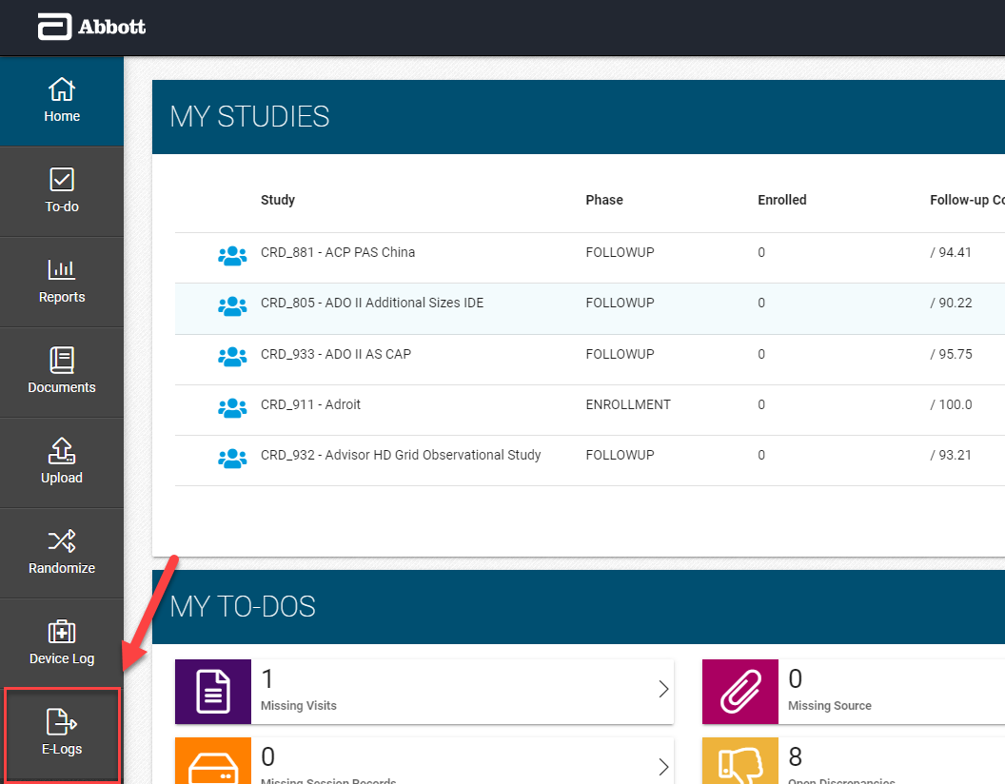

DASHBOARD

Header Bar Options
The header bar icons provide some basic functionalities for the application.

Icon | Title | Function
 | Toggle Menu | Hide or show the module titles in the side navigation bar on the left
 | Options | Display icons Help, About and Logout
 | User Manual | Download the user manual
 | About | Display additional information about the application
 | Logout | Close the application

Navigation bar will appear on the left with specified modules.

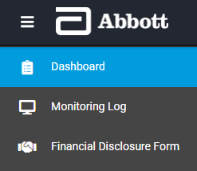

Graphs

Aging Metrics
Displays aging metrics for Site Users with the # of days past due (Days since assignment). Hover over the graph to display the specific counts.

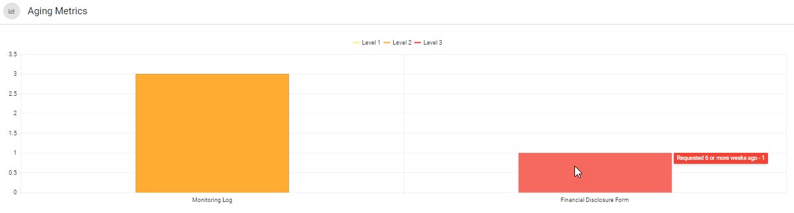

Completeness Progress
Displays user’s completed action items in the form of a percentage.

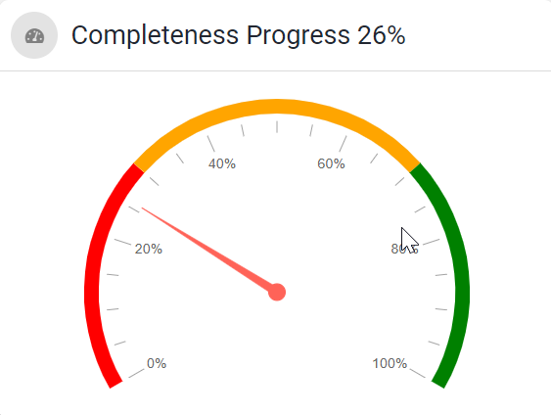

Study Site Doc Summary
Displays Study, Site, Site Status, Doc Type, Overall Doc Status icon, Site Action Items and Doc Detail Launch Icon.

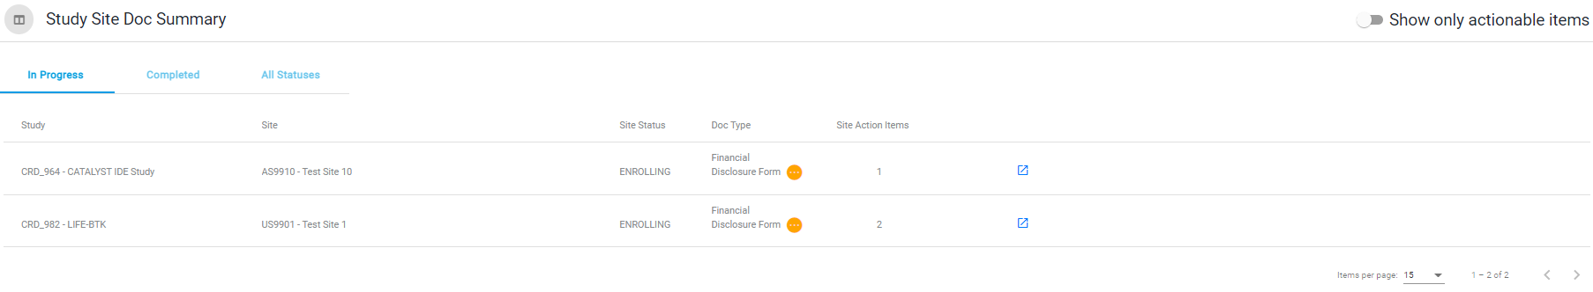


Launch the detailed doc for a single study site by clicking on the launch doc icon:

Overall Doc Status
Study Site Doc Summary can be filtered using the quick filters directly above the study-site doc list.



- In Progress: Displays study-site docs that currently have outstanding action items.
- Completed: Displays study-site docs that are completed with no outstanding action items.
- All Statuses: Displays study-site docs at any status.

You can identify the Overall Doc Status using the icon to the right of the Doc Type in the Study Site Doc Summary grid.

- In Progress: 
- Completed: 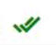

MONITORING LOG MODULE

Header Bar Options
The header bar icons provide some basic functionalities for the application.

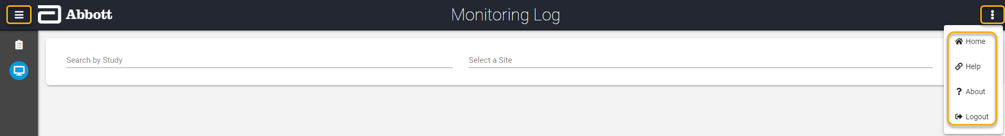

Icon | Title | Function
 | Toggle Menu | Hide or show the module titles in the side navigation bar on the left
 | Options | Display icons Home, Help, About and Logout
 | Home | Navigate to the Dashboard view
 | Help | Download the user manual
 | About | Display additional information about the application
 | Logout | Close the application

Visit Filters
There are multiple filters to limit the Study selection list.

- Filters:
- Study* – Enables the user to view logs for the studies that they have access to and limits the Site filter according the study selection.
- Site* – Limited by the Study selection. Displays all sites with log entries that the user has access to.
- Visit – Options to choose from Site Initiation Visit, Periodic Monitoring Visit and Close-out visit based on the SMA Visit details.
- Start Date – Limits the Monitoring Log Module to only display visit dates on or after the specified start date.
- End Date – Limits the Monitoring Log Module to only display visit dates before and up to the specified end date.
* Required fields

Monitoring Log Detail

Workflow
- Monitor acknowledgement will set the log entry status to Ready for Site
- Site acknowledgement will finalize the log entry status to Completed

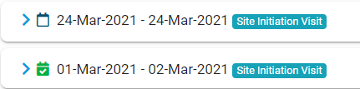
The icon to the left of the visit identifies that the Monitoring Visit Report has been completed, which locks the visit and all associated log entries.

Icon | Title | Description
 | In Progress | Visits and/or associated documentation are still on-going
 | Completed | Visits and associated documentation are completed, and all associated log entries are locked

Quick Filters
Monitoring Log view can be filtered using the quick filters located above the monitoring log visit grid. It displays status counts for statuses Ready for Site and Completed to keep track of the entries at each of those statuses for all visits displayed.



Site Acknowledgment
Once the Monitoring Acknowledgement is complete and the Site Contact is assigned, the status of the specified log entry will change from Ready for Monitor to Ready for Site for the assigned site contact to acknowledge the entry. This activity can be only done by the Assigned Site Contact by either clicking on Site Sign or by clicking on the name link itself as shown below.

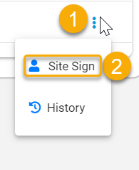

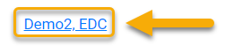
Or

The Site Acknowledgement window displays the Visit Type, Visit Date, and Assigned Monitor and requires entry of the site contact’s User Name and Password.

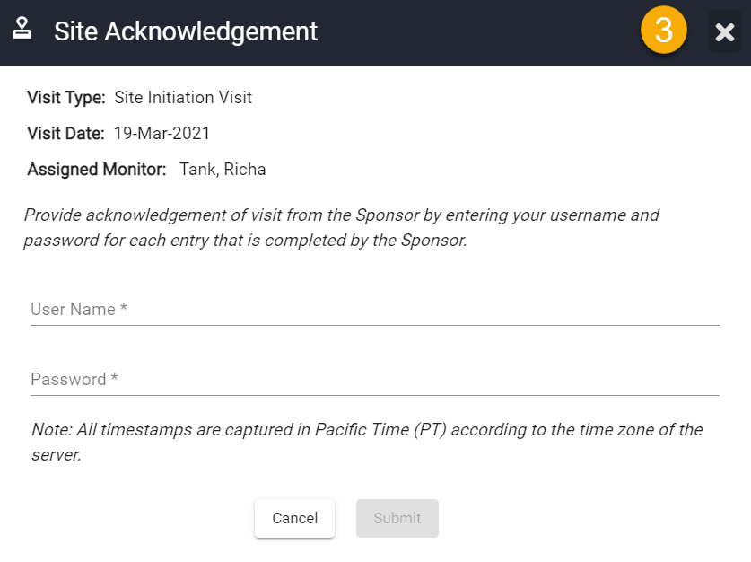

- User Name and Password: Enter your Abbott EDC Study Portal user name and password and then click Submit to acknowledge the log entry.

Note: All Timestamps are captured in Pacific Time (PT) according to the time zone of the server.

Once the acknowledgement is submitted, the log entry will be updated to display the timestamp of the Site Acknowledgment and Completed status.

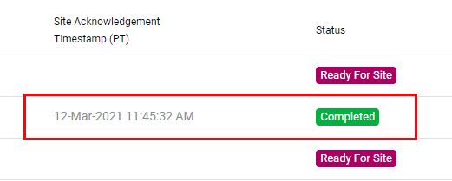
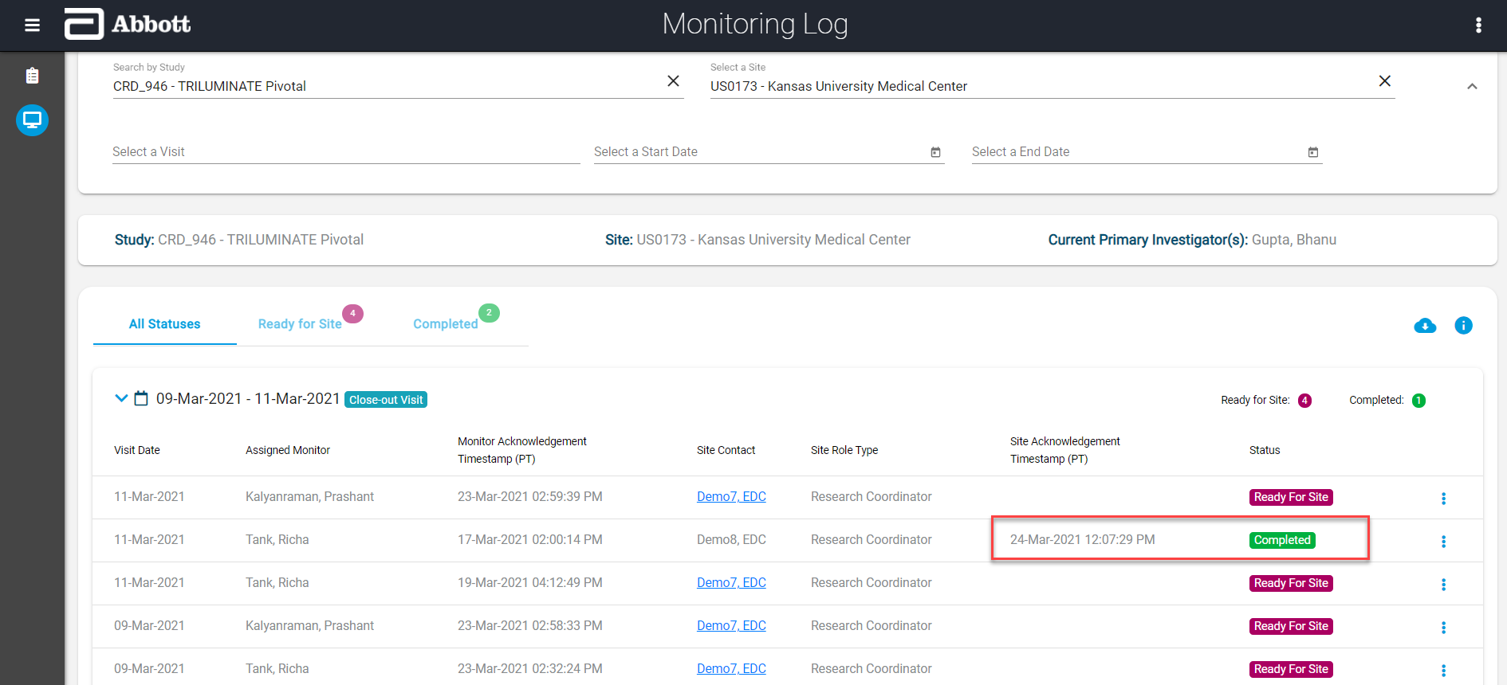

Generating a Report
The reports can be generated on-demand from the application for storage in the site’s regulatory binder. *

To generate the report on-demand:

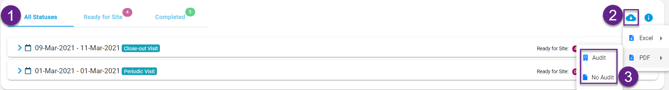

- Change the quick filter selection, if necessary
- Click on the cloud icon
- Select your output type (Excel or PDF) *
- Select Audit (to include the audit trail) or No Audit *

* It is recommended that the report in the regulatory binder or provided to any auditor be a PDF with the audit trail included.

Note: All Timestamps are captured in Pacific Time (PT) according to the time zone of the server.

Report output with Audit Trail:

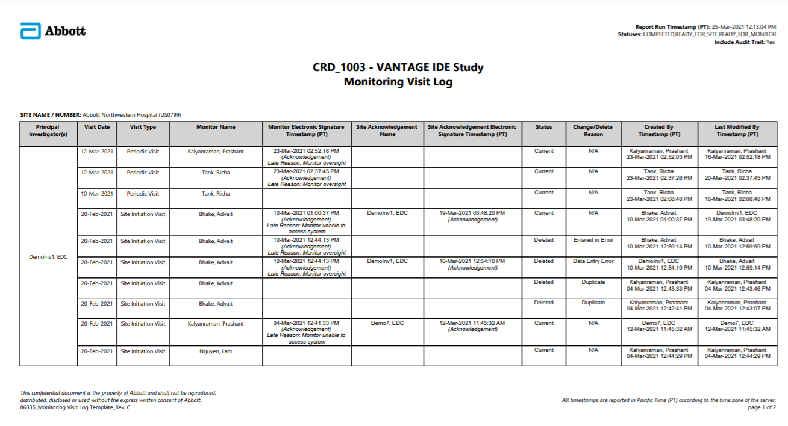

Report output without Audit Trail:

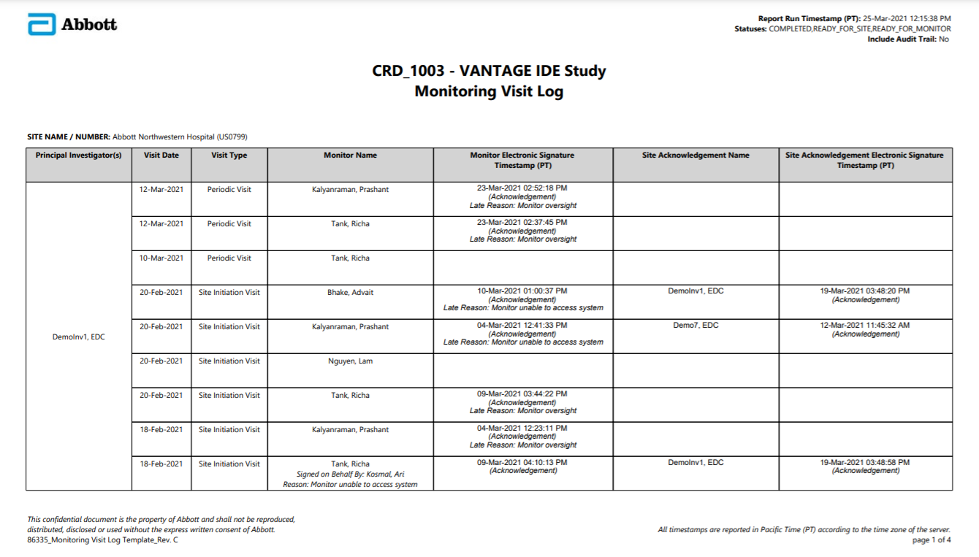

FINANCIAL DISCLOSURE FORM MODULE

Header Bar Options
The header bar icons provide some basic functionalities for the application.

Icon | Title | Function
 | Toggle Menu | Hide or show the module titles in the side navigation bar on the left
 | Options | Display icons Help, About and Logout
 | Home | Navigate to the Dashboard view
 | User Manual | Download the user manual
 | About | Display additional information about the application
 | Logout | Close the application

Study and Site Filters
As the Financial Disclosure Form information is tracked separately for each study-site, a study and site must be selected in this module. If the module is launched from a study-site in the Dashboard, the study and site will be selected automatically.

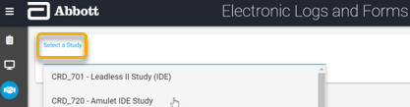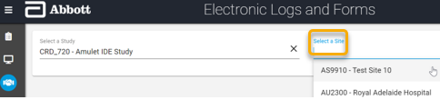
Filters:
- Study* – Enables the user to view forms for the studies that they have access to and limits the Site filter according to the study selection.
- Site* – Limited by the Study selection. Displays all sites that the user has access to.
* Required fields

Financial Disclosure Form

Homepage Overview
Once study and site are selected, the Financial Disclosure Form homepage displays the following:

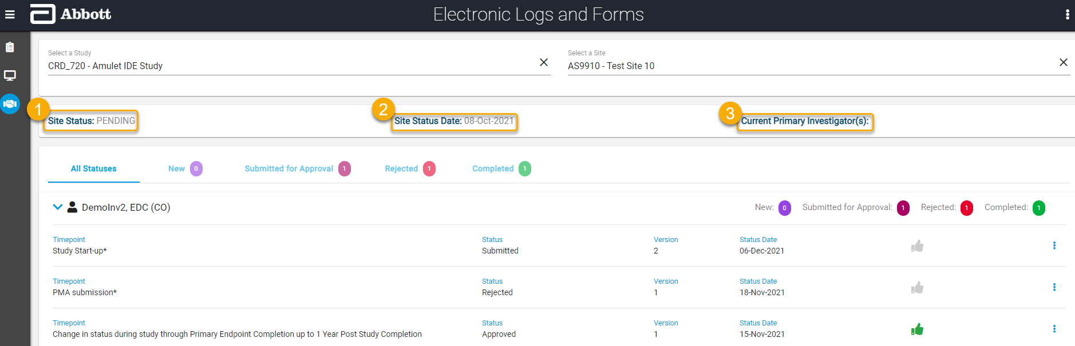

- Site Status - The current status for the study-site.
- Site Status Date - The effective date of the current status.
- Current Primary Investigator - The active PI(s) for the study-site.

Note: Research Coordinators (RCs) at the sites can view and download all personnel at their assigned study-site with an electronic Financial Disclosure Form requirement. Other roles will only be able to see their own forms.

Click on the below quick filters to filter the forms by status:

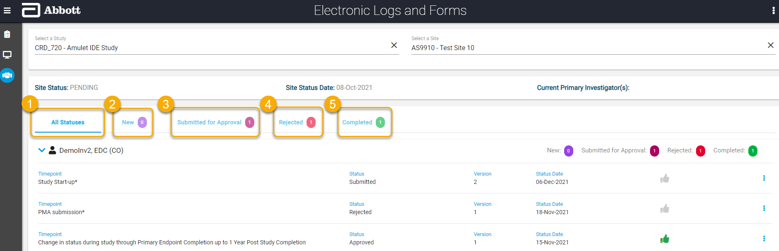

- All Statuses - Displays forms at any status.
- New - Displays blank forms that are at a New status.
- Submitted for Approval - Displays forms that the physician has submitted and are awaiting Sponsor review.
- Rejected - Displays forms that have been rejected by the Sponsor and need to be corrected and re-submitted.
- Completed - Displays forms that have been approved by the Sponsor.

Expand any user by clicking on the > arrow next to their name to view the information listed below:

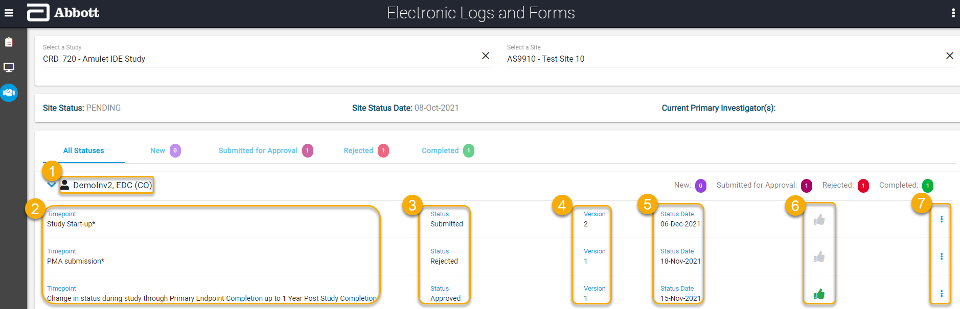

- Site Personnel Name - The study-site personnel who has an eFDF requirement.
- Timepoint - The 3 different Timepoints for which the user can submit an FDF.
- Status – The current status for the Financial Disclosure Form.
- Submitted – The form has been submitted and is awaiting Sponsor review.
- Rejected – The form has been rejected by the Sponsor and needs to be corrected and re-submitted.
- Approved – The form has been approved by the Sponsor and is considered “Completed”.
- Version – The current version of that form. Each time a form is submitted and approved, the version number will increment sequentially.
- Status Date - When the status was last updated.
- Thumbs Up icon - If this icon is green, the form was submitted with zero disagreements and there is no potential financial interest.
- Options icon - When you expand the options, you can select appropriate actions for that Timepoint.

Creating a New Form
To create a new form, the assigned site personnel will expand the options menu for the applicable Timepoint and click “Create Form”.

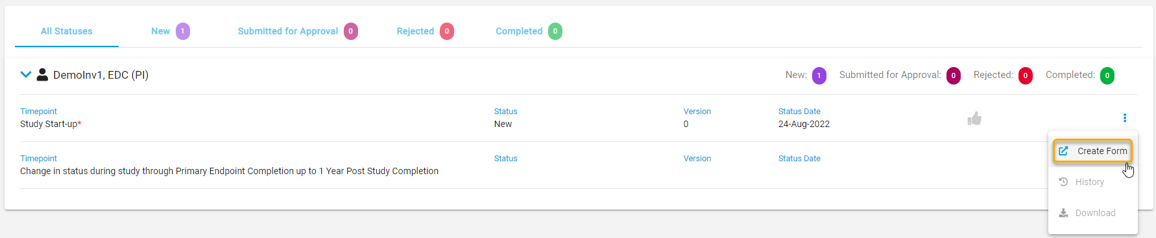

This option is available for the following scenarios:
- There is no form.
- Form status is New.
- Form status is Approved.

A new form will appear with the following elements:

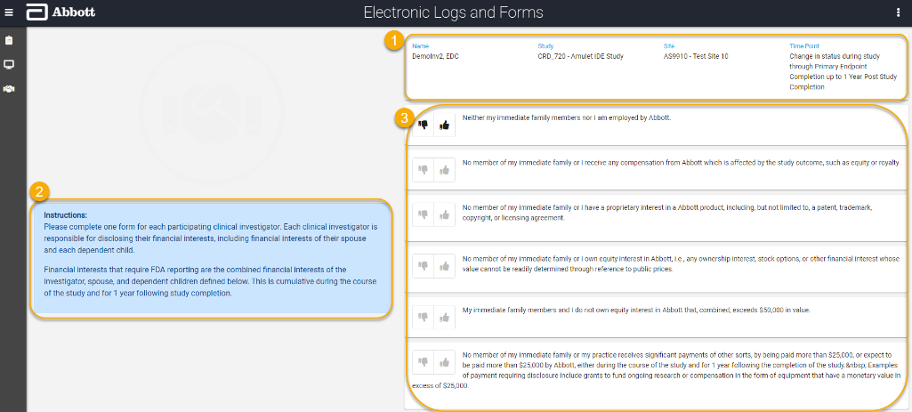
- Page header
  - Name
  - Study
  - Site
  - Timepoint
- Instructions for completing the form.
- The statements that require agreement or disagreement to complete the form.

The site personnel will click the thumbs up if they agree with the statement or thumbs down if they disagree. For each disagreement, an explanation will be required. Below is an example of a completed form:

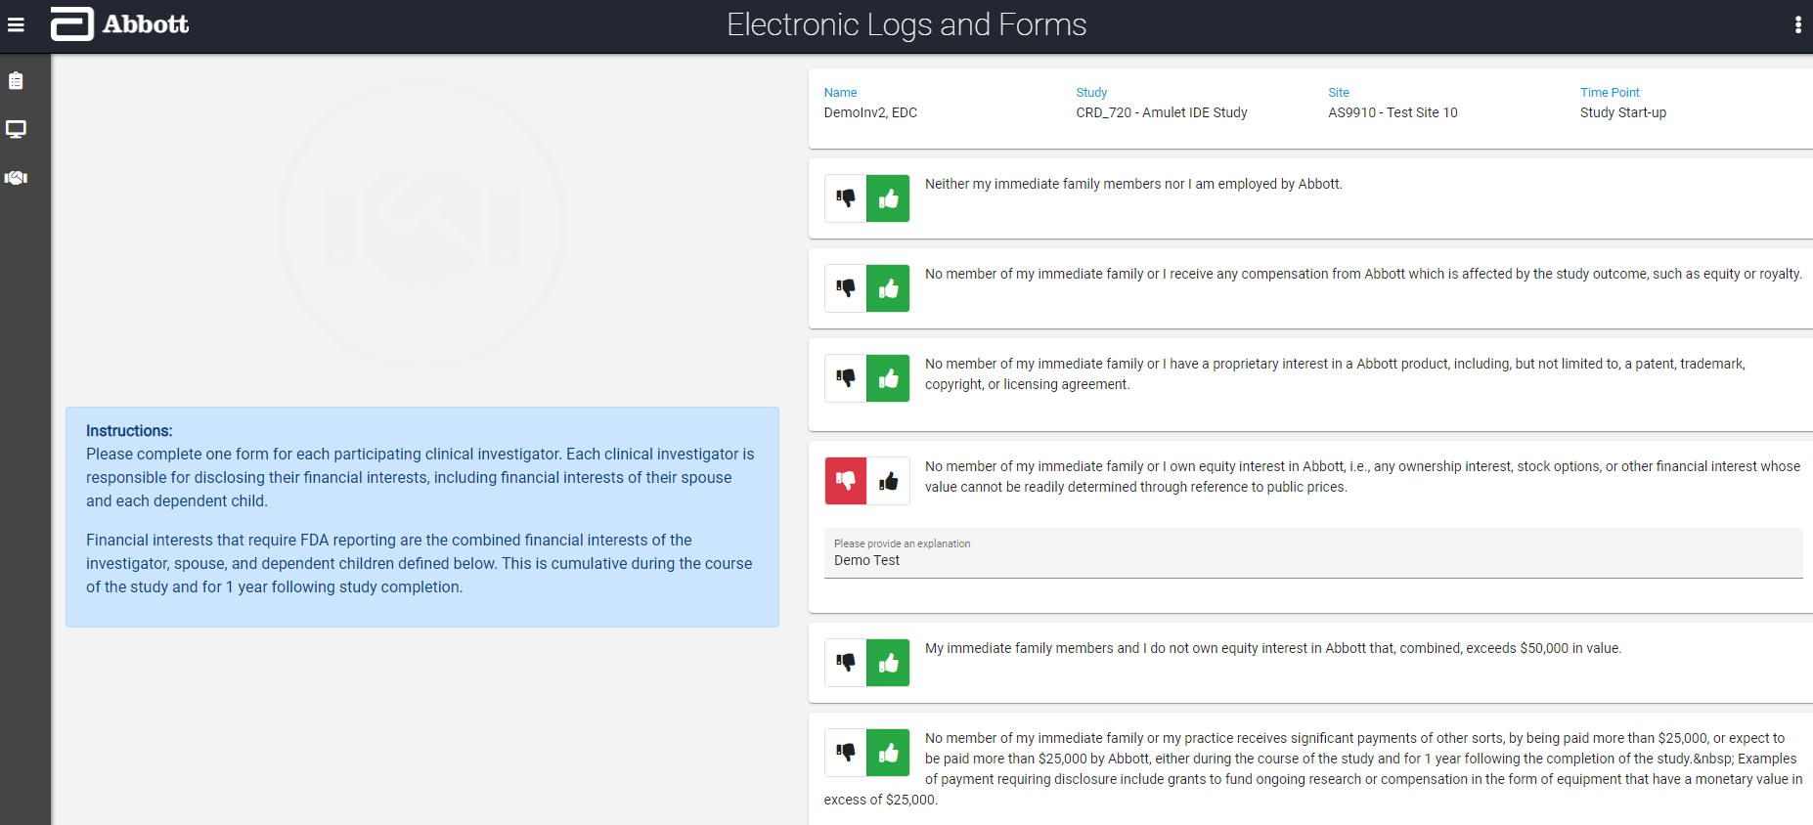

Directly beneath the completed form, the site personnel must attest to their responses by entering their Portal credentials as an e-Signature.

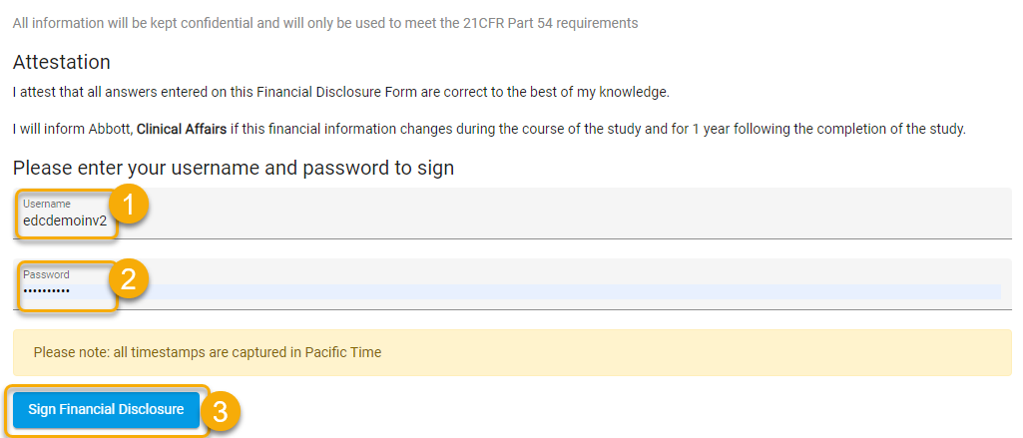
- Enter Username
- Enter Password
- Click “Sign Financial Disclosure”

Editing an Existing Form
To edit an existing form, expand the options menu for the applicable Timepoint and click “Edit Form”.

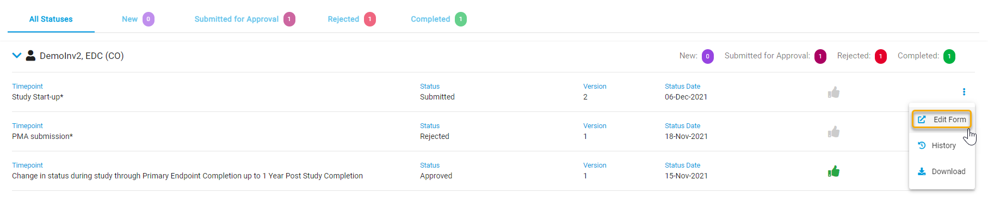

This option is only available when:
- Form status is Submitted.
- Form status is Rejected.

The existing form will open for editing and the Attestation must be completed again to re-submit.

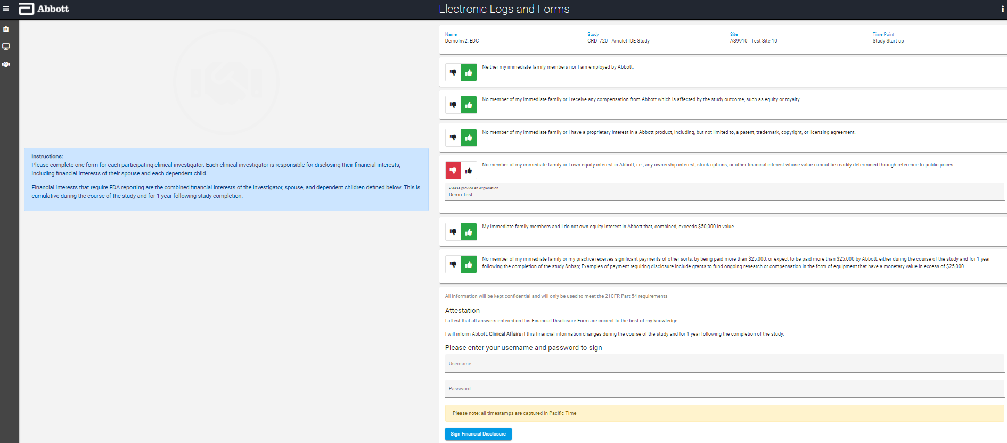

Viewing the History
To view the history of all form submissions and status changes, expand the options menu for the applicable Timepoint and click “History”.

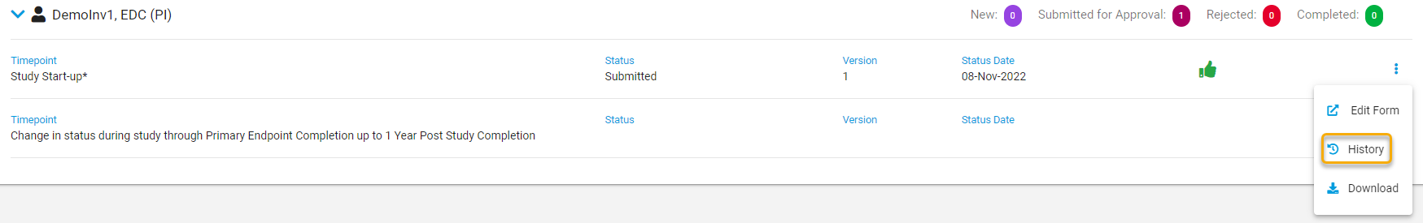

When you select History, it will show you the complete history of the forms that have been submitted on the left with details of the selected form on the right. For each form you will be able to see:

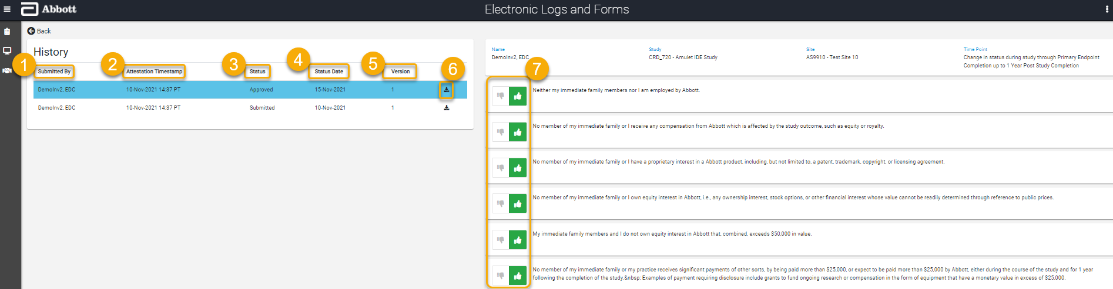

- Submitted By - The site personnel who submitted and signed this form instance.
- Attestation Timestamp - The exact date and time* the form was signed.
- Status - The status for that instance of the form.
- Status Date – When the status was updated.
- Version - The version of that instance of the form.
- Download button - This button allows you to download the selected form.
- Form Details - A green thumbs up shows an agreement and a red thumbs down shows a disagreement with the explanation entered below it.

* All Timestamps are captured in Pacific Time (PT) according to the time zone of the server.
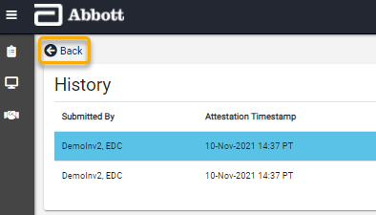

When you are on the History page, you can use the “Back” button to return to the Financial Disclosure Form homepage.

Downloading a PDF
To download a PDF of the latest form, expand the options menu for the applicable Timepoint and click “Download”.

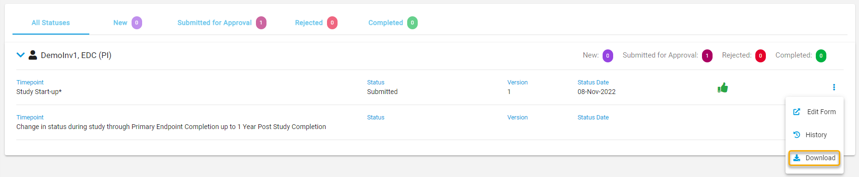
Note: Use the “History” option to download older forms.

When you use the “Download” option, a PDF similar to the image below will be produced:
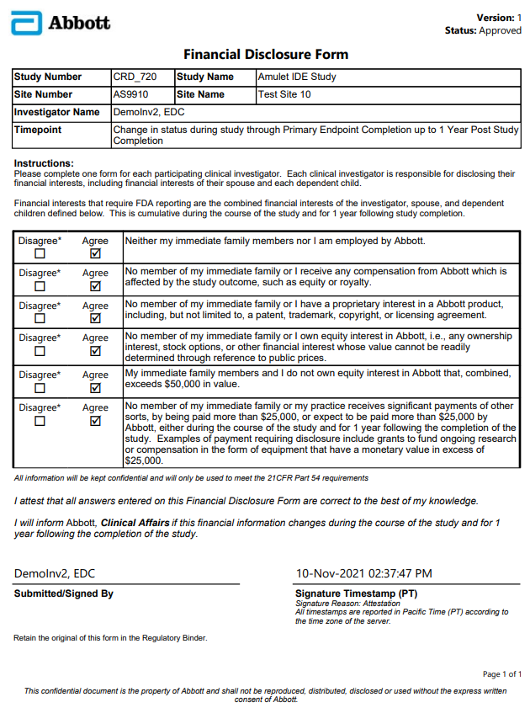

- If there is a disagreement, the related explanation will be visible directly beneath the associated disagreement.

- The electronic Signature Timestamp* is displayed with a Signature Reason of “Attestation”.

- This PDF can be printed and stored in the site’s regulatory binder.

- The form is automatically sent to the Sponsor for review upon submission.

- When the form is Approved by the Sponsor, it becomes part of the formal record.

* All Timestamps are captured in Pacific Time (PT) according to the time zone of the server.

